Project Objective
The objective of this project was to explore how an agentic workflow can be used in software testing using n8n and Playwright. The goal was to take a manual test case, convert it into a structured and automation-ready test case through multiple agents, and then generate a Playwright test script from that output. Along with this, the project also aimed to understand how such an agentic workflow could fit into the Software Testing Life Cycle (STLC) and what requirements are needed for an agent to automate test cases reliably.

Tools Used
The project used n8n Cloud to build the multi-agent workflow and OpenAI Chat Model inside n8n to power the agents. Playwright was used to generate and run the automation test script, and VS Code was used to view and manage the generated test file. Since the local testing setup required Windows tools, Parallels on Mac was used to run a Windows environment for Playwright execution. In addition, simple text files were used to store manual test cases, notes, and project outputs.

Workflow Overview
The workflow started with a manual test case written in a simple text format. This manual test case was passed into an n8n workflow through a sample input node. The first agent, Test Case Analyzer, read the manual test case and converted it into a structured JSON format. The second agent, Automation Feasibility Agent, checked whether the test case could be automated and identified the missing information, required selectors, assertions, and automation steps. The third agent, Playwright Generator Agent, used that automation-ready output to generate a Playwright test script in JavaScript. The generated script was then saved and executed in a Playwright setup in Parallels Windows to see whether the workflow could produce a runnable automation output.

Agents
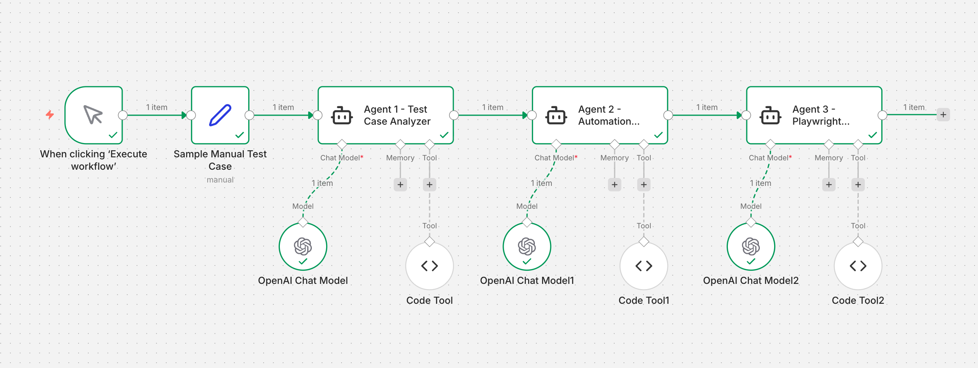

Agent 1 - Test Case Analyzer
What it did
The first agent in the workflow was the Test Case Analyzer. Its role was to take the manual test case written in plain text and convert it into a structured JSON format. It extracted the important parts of the test case such as the test case ID, title, preconditions, test steps, expected result, test data, and environment. This made the manual test case easier to use in the next stages of the workflow.

Screenshot
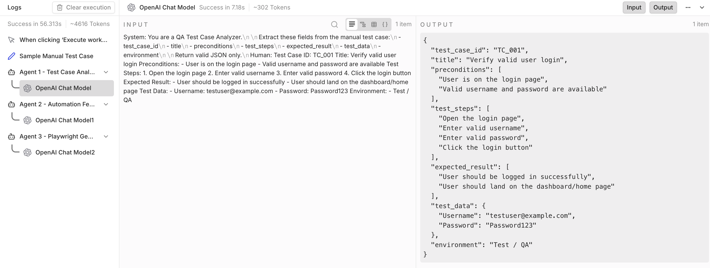

Output
{
"test_case_id": "TC_001",
"title": "Verify valid user login",
"preconditions": [
"User is on the login page",
"Valid username and password are available"
],
"test_steps": [
"Open the login page",
"Enter valid username",
"Enter valid password",
"Click the login button"
],
"expected_result": [
"User should be logged in successfully",
"User should land on the dashboard/home page"
],
"test_data": {
"Username": "testuser@example.com",
"Password": "Password123"
},
"environment": "Test / QA"
}

Agent 2 - Automation Feasibility Agent
What it did
The second agent in the workflow was the Automation Feasibility Agent. Its role was to take the structured output from Agent 1 and analyze whether the test case could be automated. It identified what additional information would be needed for automation, such as the real application URL, selectors, assertions, and setup requirements. It also converted the structured test case into an automation-ready format that could be used for script generation in the next step.

Screenshot
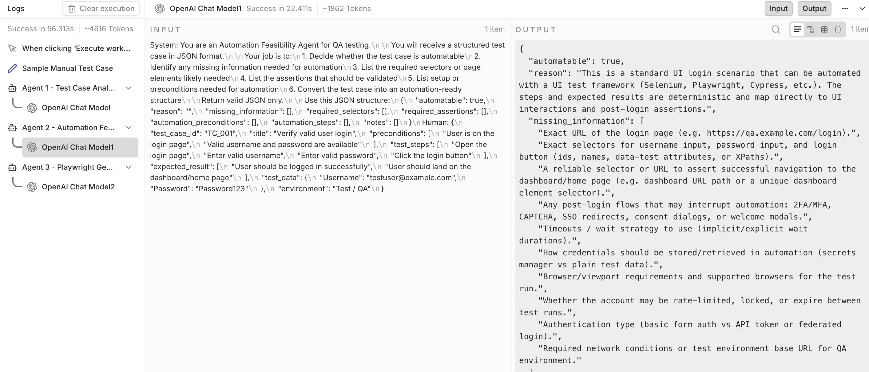

Output
{
"automatable": true,
"reason": "This is a standard UI login scenario that can be automated with a UI test framework (Selenium, Playwright, Cypress, etc.). The steps and expected results are deterministic and map directly to UI interactions and post-login assertions.",
"missing_information": [
"Exact URL of the login page (e.g. https://qa.example.com/login).",
"Exact selectors for username input, password input, and login button (ids, names, data-test attributes, or XPaths).",
"A reliable selector or URL to assert successful navigation to the dashboard/home page (e.g. dashboard URL path or a unique dashboard element selector).",
"Any post-login flows that may interrupt automation: 2FA/MFA, CAPTCHA, SSO redirects, consent dialogs, or welcome modals.",
"Timeouts / wait strategy to use (implicit/explicit wait durations).",
"How credentials should be stored/retrieved in automation (secrets manager vs plain test data).",
"Browser/viewport requirements and supported browsers for the test run.",
"Whether the account may be rate-limited, locked, or expire between test runs.",
"Authentication type (basic form auth vs API token or federated login).",
"Required network conditions or test environment base URL for QA environment."
],
"required_selectors": [
{
"name": "login_page_url",
"example": "https://qa.example.com/login",
"note": "Exact URL needed"
},
{
"name": "username_input",
"examples": ["#username", "input[name='username']", "input[data-test='username']"]
},
{
"name": "password_input",
"examples": ["#password", "input[name='password']", "input[data-test='password']"]
},
{
"name": "login_button",
"examples": ["#login", "button[type='submit']", "button[data-test='login-btn']"]
},
{
"name": "login_error_message",
"examples": [".login-error", "#error", "div[role='alert']"],
"note": "Used to assert absence of error"
},
{
"name": "dashboard_unique_element",
"examples": ["#dashboard", "div.dashboard-header", "h1:has-text('Dashboard')", "nav[aria-label='Main']"],
"note": "A stable selector only present when logged in"
},
{
"name": "user_profile_indicator",
"examples": ["#user-avatar", ".user-name", "a[href='/profile']"],
"note": "Optional additional assertion to confirm the correct user"
}
],
"required_assertions": [
"Current URL contains or equals expected dashboard/home URL (e.g. contains '/dashboard' or equals 'https://qa.example.com/home').",
"A unique dashboard element is visible/present on the page.",
"No login error message is visible on the login page after submission.",
"Optional: user profile indicator or username is visible and matches the logged-in user (e.g. displays 'testuser@example.com' or 'Test User').",
"Optional: HTTP response/status or network call indicates successful login (if available via network interception).",
"Optional: Session cookie or token is present (if the test framework can access cookies) and has expected attributes (name, expiry, domain)."
],
"automation_preconditions": [
"Test user account exists with the provided credentials and is not locked/expired.",
"Test environment (QA) is reachable and seeded as required.",
"Credentials are accessible securely to the automation runner (e.g. from environment variables or secret manager).",
"No MFA/CAPTCHA/SSO is required for the account, or there is a deterministic bypass for automation.",
"Test runner has network access and correct base URL configured.",
"Browser driver or automation framework is installed and configured (Selenium WebDriver, Playwright, Cypress, etc.).",
"A clean state for the browser before test (cookies/localStorage cleared) or a deterministic state management approach."
],
"automation_steps": [
{
"step_number": 1,
"action": "navigate",
"description": "Open the login page URL",
"selector": "login_page_url",
"value": null,
"wait_for": "page_load",
"assertion_after": "current_url matches login page URL or login form visible"
},
{
"step_number": 2,
"action": "fill",
"description": "Enter valid username",
"selector": "username_input",
"value": "testuser@example.com",
"wait_for": "element_visible",
"assertion_after": "username input contains the entered value"
},
{
"step_number": 3,
"action": "fill",
"description": "Enter valid password",
"selector": "password_input",
"value": "Password123",
"wait_for": "element_visible",
"assertion_after": "password input contains the entered value (or masked)"
},
{
"step_number": 4,
"action": "click",
"description": "Click the login button",
"selector": "login_button",
"value": null,
"wait_for": "navigation_or_element",
"wait_details": "wait for dashboard_unique_element to be visible or URL to change to dashboard within timeout",
"assertion_after": "no login error message visible"
},
{
"step_number": 5,
"action": "assert",
"description": "Verify user is logged in successfully and on dashboard/home page",
"selector": "dashboard_unique_element",
"value": null,
"wait_for": "element_visible",
"assertion_after": "dashboard element visible AND current URL contains expected dashboard path"
},
{
"step_number": 6,
"action": "optional_assert",
"description": "Verify user identity (optional)",
"selector": "user_profile_indicator",
"value": "testuser@example.com",
"wait_for": "element_visible",
"assertion_after": "profile indicator displays expected username or profile"
}
],
"notes": [
"Store credentials in a secrets manager or environment variables; avoid hard-coding sensitive data in test code.",
"If 2FA or CAPTCHA is present in QA, either use a test account with these disabled or provide a deterministic bypass (test-only flag or test API).",
"Use explicit waits for the dashboard element or URL change rather than fixed sleeps to reduce flakiness.",
"Add retry/backoff logic for intermittent network issues and increase timeout thresholds in CI.",
"Prefer stable selectors (data-test, data-qa attributes). If only CSS/XPath available, collaborate with devs to add test-friendly attributes.",
"Consider teardown steps if logging in changes user state (e.g., logout at end of test or reset test user state via API).",
"If possible, validate login via API before/after UI steps to accelerate checks and reduce UI dependency for setup/teardown.",
"Cross-browser differences: ensure selectors and waits work in all targeted browsers; run in headless and headed modes in CI."
]
}

Agent 3 - Playwright Generator Agent
What it did
The third agent in the workflow was the Playwright Generator Agent. Its role was to take the automation-ready output from Agent 2 and convert it into a Playwright test script in JavaScript. The generated script included the basic Playwright test structure, placeholder URL, placeholder selectors, test data, and assertions for a successful login flow. This showed how an agentic workflow can move from a manual test case all the way to a runnable automation script draft.

Screenshot
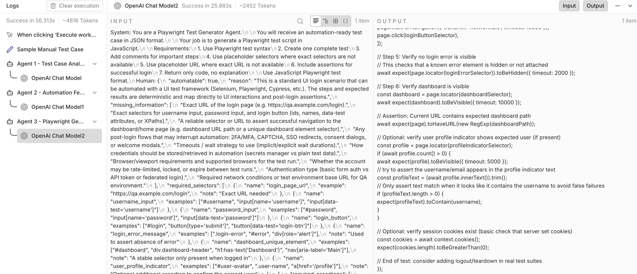

Generated Playwright Code
const { test, expect } = require('@playwright/test');

test('UI Login - should authenticate and land on dashboard', async ({ page, context }) => {
// Configuration / placeholders
const loginUrl = process.env.LOGIN_URL || 'https://example.com/login'; // <-- replace with real login URL
const dashboardPath = process.env.DASHBOARD_PATH || '/dashboard'; // <-- adjust to expected dashboard path
const username = process.env.TEST_USERNAME || 'testuser@example.com'; // store real creds in env vars
const password = process.env.TEST_PASSWORD || 'Password123'; // store real creds in env vars

// Placeholder selectors (choose the one that matches your app)
const usernameSelector = 'input[name="username"], #username, input[data-test="username"]';
const passwordSelector = 'input[name="password"], #password, input[data-test="password"]';
const loginButtonSelector = 'button[type="submit"], #login, button[data-test="login-btn"]';
const loginErrorSelector = '.login-error, #error, div[role="alert"]';
const dashboardSelector = 'nav[aria-label="Main"], #dashboard, div.dashboard-header, h1:has-text("Dashboard")';
const profileIndicatorSelector = 'a[href="/profile"], #user-avatar, .user-name';

// Step 1: Navigate to login page
await page.goto(loginUrl, { waitUntil: 'networkidle' });

// Assert login form is visible
await expect(page.locator(usernameSelector)).toBeVisible({ timeout: 5000 });
await expect(page.locator(passwordSelector)).toBeVisible({ timeout: 5000 });

// Step 2: Enter username
await page.fill(usernameSelector, username);

// Verify the username input contains the entered value
await expect(page.locator(usernameSelector)).toHaveValue(username);

// Step 3: Enter password
await page.fill(passwordSelector, password);

// Verify password input contains the entered value (value check works even if masked)
await expect(page.locator(passwordSelector)).toHaveValue(password);

// Step 4: Click login and wait for navigation / dashboard element
await Promise.all([
page.waitForNavigation({ waitUntil: 'networkidle', timeout: 15000 }),
page.click(loginButtonSelector),
]);

// Step 5: Verify no login error is visible
// This checks that a known error element is hidden or not attached
await expect(page.locator(loginErrorSelector)).toBeHidden({ timeout: 2000 });

// Step 6: Verify dashboard is visible
const dashboard = page.locator(dashboardSelector);
await expect(dashboard).toBeVisible({ timeout: 10000 });

// Assertion: Current URL contains expected dashboard path
await expect(page).toHaveURL(new RegExp(dashboardPath));

// Optional: verify user profile indicator shows expected user (if present)
const profile = page.locator(profileIndicatorSelector);
if (await profile.count() > 0) {
await expect(profile).toBeVisible({ timeout: 5000 });

// Try to assert the username/email appears in the profile indicator text
const profileText = (await profile.innerText()).trim();

// Only assert text match when it looks like it contains the username to avoid false failures
if (profileText.length > 0) {
expect(profileText).toContain(username);
}
}

// Optional: verify session cookies exist (basic check that server set cookies)
const cookies = await context.cookies();
expect(cookies.length).toBeGreaterThan(0);

// End of test: consider adding logout/teardown in real test suites
});

Playwright Execution Result
What happened
The generated Playwright test script was saved into a local Playwright project and executed in the Parallels Windows environment. The Playwright setup worked correctly, the browser launched, and the test started running. This confirmed that the agent-generated script was in a runnable format and could be executed through Playwright.

Screenshot
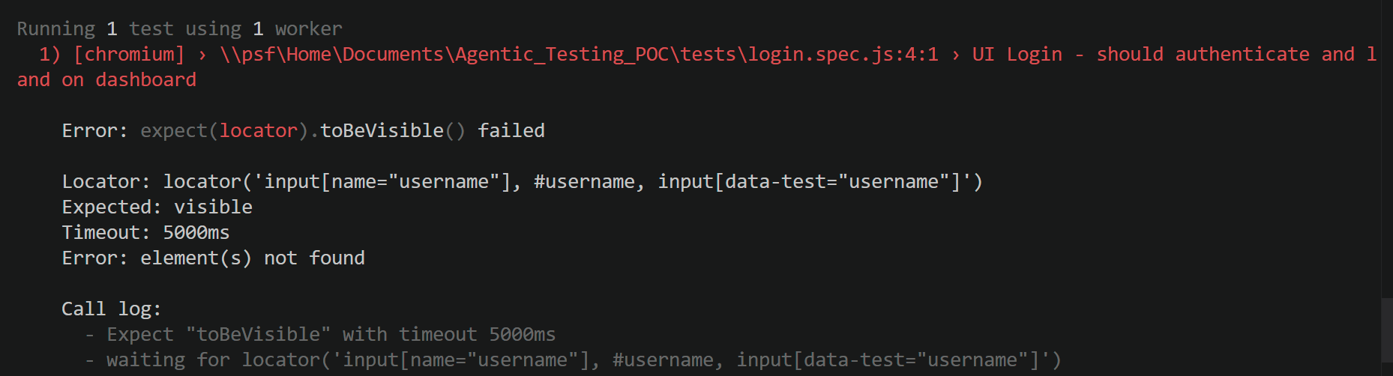.
Why it failed / limitation
The test failed because the script used a placeholder login URL and placeholder selectors instead of the actual application URL and real page element selectors. Since no real site URL was available, Playwright could not find the username field on the page and stopped at the visibility check step. This means the workflow successfully generated and ran a valid automation draft, but final test success would require real application details such as the exact login URL, working selectors, and environment-specific information.

STLC Mapping
The agentic workflow created in this project can be mapped to the Software Testing Life Cycle (STLC) in a simple end-to-end way. The process begins with Requirement Understanding, where the testing goal is identified. It then moves to Test Case Design, where the manual test case is written. In the Test Case Analysis stage, Agent 1 reads the manual test case and converts it into structured JSON. In the Automation Feasibility Check stage, Agent 2 determines whether the test case is automatable and identifies the missing inputs, selectors, assertions, and setup needs. In the Test Script Generation stage, Agent 3 generates the Playwright automation script. This is followed by Test Execution, where the script is run in the Playwright environment. Finally, in Result Review and Gap Identification, the execution outcome is reviewed to understand whether the failure is due to missing environment details, wrong selectors, missing URLs, or a real application issue.

Agent Automation Requirements
For an agent to convert a manual test case into an automation-ready test case and finally into a Playwright script, it needs certain inputs and supporting details. These include the exact application URL, full manual test case details such as title, preconditions, steps, expected result, test data, and environment, and the real selectors for the page elements involved in the test. The agent also needs clear assertions that define what should be validated at the end of the test. In addition, it needs environment details such as browser requirements, test account access, and any login conditions like MFA, SSO, or CAPTCHA. Setup and cleanup requirements are also important so that the test can run in a controlled and repeatable way. Without these details, the agent can generate a useful automation draft, but it cannot produce a fully reliable final script.

Key Learnings
This project showed that an agentic workflow can help reduce manual effort in the early stages of test automation. A manual test case can be converted into a structured format, checked for automation feasibility, and turned into a first draft of a Playwright script using multiple agents in n8n. It also showed that AI-generated test scripts can be useful as a starting point, especially for creating the base structure, test flow, and assertions. At the same time, the project made it clear that automation still depends heavily on real application details such as URLs, selectors, credentials, and validation points. Another important learning was that the workflow can fit naturally into the STLC, especially in the test analysis, feasibility, and script generation stages.

Limitations / Next Steps
The main limitation in this project was that a real application URL and actual selectors were not available, so the Playwright script could not be fully validated against a live login page. Because of that, the final script remained a runnable draft rather than a fully working production test. Another limitation is that AI-generated outputs still need human review to confirm whether the selectors, assertions, and steps match the actual application behavior. As a next step, this workflow can be extended by adding a real website or test application, replacing placeholder selectors with actual ones, and then re-running the Playwright test for a full end-to-end validation. The workflow can also be improved further by adding another review or validation agent, supporting multiple test case types, and generating more reusable Playwright test templates.

